

Structural Design

(Inside View)

**Vertical corrugation**

Design#:

311*/*16

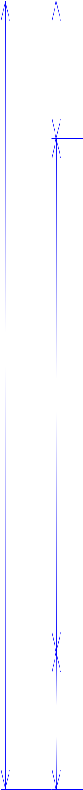

213*/*16

1313*/*16

311*/*16

**191226-02_D**

Customer:

**DeMet's Candy**

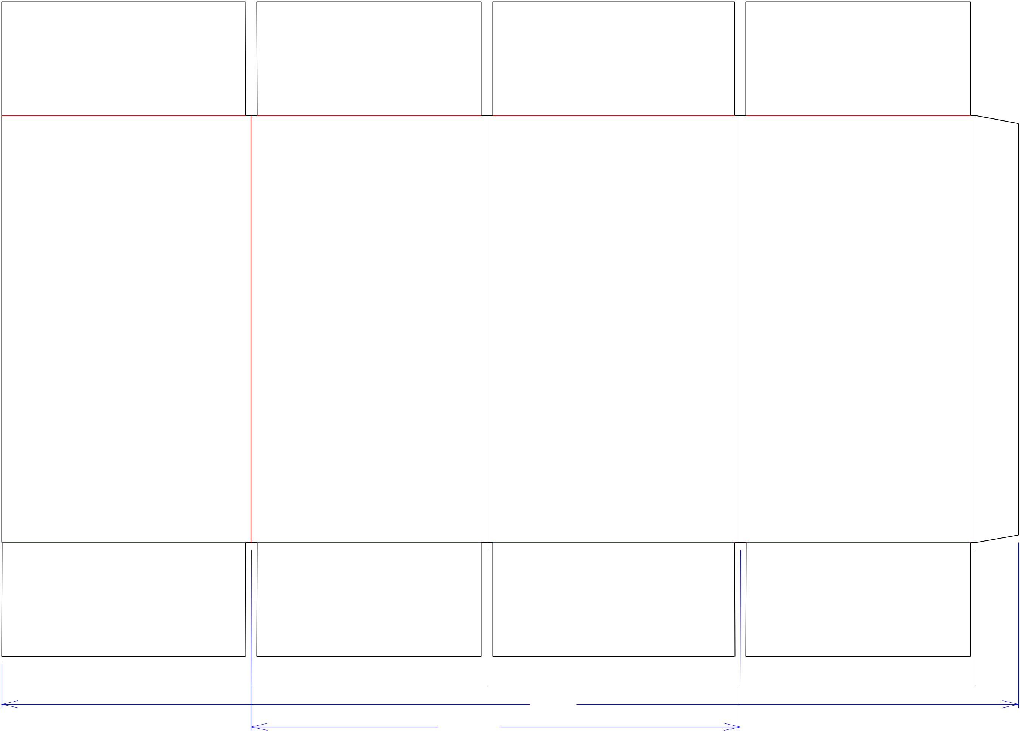

Description:

**Holiday 2020 5.2 oz Assorted Gift Box**

**SINGLE-OUT DRAWING**

Qty/Unit:

Style: **RSC**

Board: **32CK**

Combination: **35HP - 23M - 35HP**

I.D. : **8 x 7+7/16 x 13+1/2**

**O.D.: 83/8 x 713/16 x 141/4**

Area of Blank - Waste : **4.7 sq. ft.**

Waste on Blank : **2.89%**

Finished Piece Weight: **0.49 lbs./223.41g**

Over-all Blank: **21+3/16 x 32+7/8**

**No Die Required**

Notes:

 81*/*16  75*/*8  83*/*16  75*/*8  13*/*8 

327*/*8

1513*/*16

Revision Info: **[D] 01/09/2020**

**Increase width per customer - AK 1/9/20**

Designer: **Amy Kirchhoff**

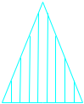

Cut Crease Crease with Matrix Cut Crease Half Knife Cut Tear Tape Perforation



Designright and Copyright of DS Smith Corrugated Packaging Ltd. This technical Specification is subject to Manufacturing tolerances. Drawing dimensions shown are crease to crease. Date printed: 01/09/2020